**May 2015 SL P1**

**Section A**

1. Construct a truth table for the following Boolean expression.  
     
    (A or B) and (not C or B*)* [4]

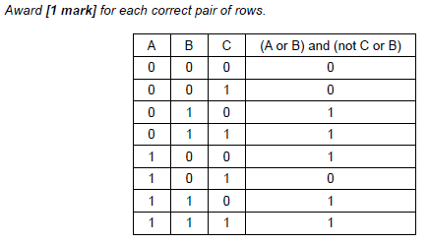

1. Outline one example of the use of a virtual private network (VPN). [3]

*Award* ***[1 mark]*** *for a relevant example and* ***[2 marks]*** *for an elaboration.*

***Example 1:***

A business can let employees work at home / employees who travel a lot/external

(non-employee) users;

Accessing the data and services (at the office);

Via secure login;

***Example 2:***

Using VPN, address is masked;

The location of the user is not known;

May be essential in delicate situations such as political protest groups working from their own country;

***Note:*** *Accept any legitimate reason for needing to be unknown.*

1. Outline how a sub-procedure can be considered an example of abstraction. [2]

*Award* ***[1 mark]*** *for details of a sub-procedure and* ***[1 mark]*** *for how it is used.*

*For example:*

A sub-procedure is a section of code in a program that does a specific job;

It can be called by name when needed without naming the details as these are wrapped in the procedure;

1. 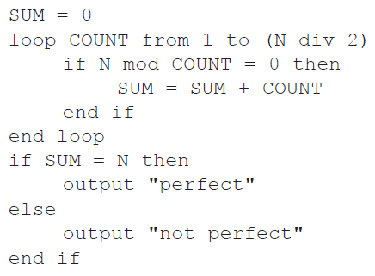Trace the following algorithmic fragment for N = 6. Show all working in a trace table.

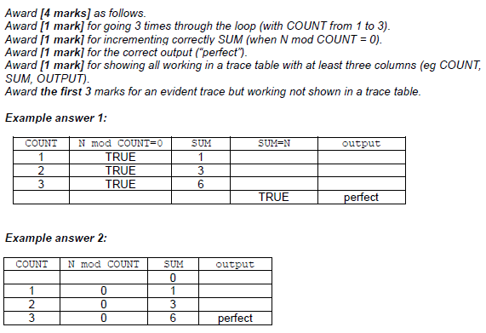

1. Outline **two** usability features in relation to the characteristics of a new laptop. [4]

*Award* ***[1 mark]*** *for each usability feature and* ***[1 mark]*** *for an elaboration clearly related to the needs of the user, taking into account that not all users have the same physical/technical capabilities, up to* ***[4 marks max]***.

*For example:*

Larger screen;

Easier to view large amounts of data without excessive scrolling or squinting / reduced eyestrain / more accessible to those with weak eyesight;

Hotkeys to control brightness, sound volume, navigation, etc;

Quick access to frequently used adjustments that aid in viewing, listening, etc without first navigating to a software-based control panel;

Size and sensitivity of touchpad;

Those with mobility or coordination issues, or simply with large hands, may need a larger and/or less sensitive pad to control the cursor;

Standard accessibility for visually impaired;

Larger text option or text to speech;

1. Describe **one** way that software developers can ensure that the users are aware of any

available updates for their products. [2]

*Award up to* ***[2 marks max]****.*

*Award* ***[1 mark]*** *for communication with user – email/ pop up etc.*

*Award* ***[1 mark]*** *for method of installation of update – automatic/ link/ in list for user to install etc.*

When the software is installed and registered (a cookie is placed on the machine);

This communicates with the software developer automatically on start up;

Messages about updates are sent back to the machine and alerts are given;

**OR**

Send an email;

With a link to the update;

1. Six students are planning their group 4 project, which is due in two days. They have to

produce a scientific report and give an animated computer presentation based on their

analysis of water samples. These water samples are to be taken from four local lakes.

1. Based on this information, identify **four** tasks that should be done by the students,  
   listing the tasks in the order that they could be completed. [2]

*Award* ***[1 mark]*** *for the correct list and* ***[1 mark]*** *for the correct order. The last two can be in any order. Accept similar descriptions of individual tasks.*

Collect samples

Analyse samples

Write report

Prepare presentation

1. Outline how **two** of the tasks identified in part (a) could be completed concurrently. [2]

*Award* ***[1 mark]*** *for the correct tasks and* ***[1 mark]*** *for outlining how they can be done concurrently*.

“Write report” and “prepare presentation” can be done at the same time as they can be performed by different students (using the same data).

1. Draw a Gantt chart to show the tasks from part (a), indicating the concurrency outlined  
   in part (b). You do not need to include the timings for the tasks. [2]

*Award* ***[1 mark]*** *for a correctly labelled chart illustrating the order of tasks from part (a) and* ***[1 mark]*** *for showing the concurrency from part (b).*

*For example:*

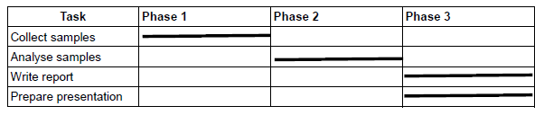

1. An insurance company holds a large database of information about its customers, including

the date of their next payment.

Once a month the database is searched to compile the following lists:

* **list 1**: customers whose next payment date will be **within** the next 30 days
* **list 2**: customers whose payment date has passed by **more than** 14 days but

**less than**, or **equal to**, 30 days

* **list 3**: customers whose payment date has passed by **more than** 30 days.

Customers who are in list 3 are flagged for deletion.

1. Construct an algorithm to illustrate the monthly process described above. [6]

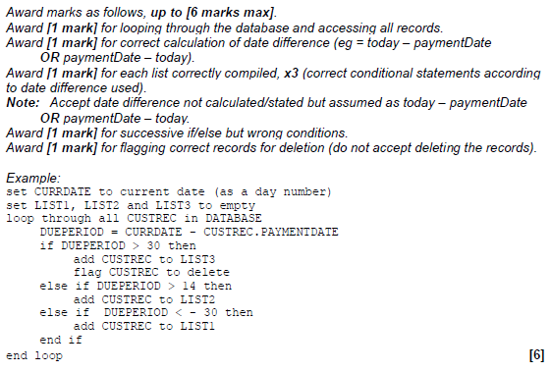

After the lists have been compiled, the following messages are sent out to customers.

* A reminder is sent to customers in list 1.
* A warning that payments are more than 14 days overdue is sent to customers in list 2.
* cancellation of contract is sent to customers in list 3.

1. Explain how the lists could be used to merge the data from the database with a

word processor to create these messages automatically for sending either by post

or by email. [4]

*Award up to* ***[4 marks max]****.*

(Using a mail merge facility);

Template for each type of reminder created in the word processor;

Lists created with customer ID;

Linked to customer details in database;

Appropriate details merged/inserted into template;

Email lists created and sent / letters printed and sent;

1. Outline the consequences of data loss to customers and to the company. [2]

*Award* ***[1 mark]*** *for a consequence of data loss to customers and* ***[1 mark]*** *for a consequence of data loss to the insurance company.*

*Example answer:*

Customers would not be reminded when they needed to pay and some may overlook payment, hence not be insured;

The company could lose customers/ruin reputation;

1. Describe **one** method that the company could use to prevent data loss. [3]

*Award marks as follows up to* ***[3 marks max]****.*

*Award* ***[1 mark]*** *for a suitable measure and* ***[2 marks]*** *for a description related to the insurance company.*

*Example answers:*

Mirror system;

All changes to the records made on two systems;

If one fails then the other holds all current data;

Off site backup;

Snapshots/backups made on a regular basis;

In the case of failure a dated/time stamped copy exists and the state up until then can be used to restore customer records;

1. Six lawyers and one secretary work together in the same building and are connected via a

LAN to a central server. Each has their own workstation.

1. Outline the concept of the Open Systems Interconnection (OSI) model in

communication across a network. [3]

*Award up to* ***[3 marks max]****.*

The OSI is a standardized system/model for network connection;

Consists of (7) layers;

Each dealing with specific parts of network communication;

For example the physical layer which defines the physical connection;

***Note:*** *Award* ***[1 mark]*** *for the purpose of any of the 7 layers.*

*If candidate lists all 7 layers with no specific example award* ***[2 marks]*** *and a further* ***[1 mark]*** *if the purpose of at least one layer is given.*

1. Outline, with an example, the function of protocols. [3]

*Award up to* ***[3 marks max]****.*

Protocols are a set of rules;

To facilitate a process being carried out correctly;

(Used in each layer to ensure communication;)

For example (in the physical layer) the protocols could define the methods for opening and closing communication;

***Note:*** *Do not accept examples which are not related to networks.*

The LAN has one server, which is connected to the internet. The workstations are connected  
 to the server by cable. There is also a wireless connection..

1. Outline **one** advantage and **one** disadvantage of allowing wireless access to the server. [4]

*Award* ***[2 marks]*** *for an advantage with an elaboration and* ***[2 marks]*** *for a disadvantage with an elaboration, up to* ***[4 marks max]****.*

*For example:*

An advantage is that lawyers can access quickly with mobile devices;

Anywhere in the building and do not need to be at the workstation;

Users can logon with their own devices (if properly configured);

More familiar with interface/functions;

One disadvantage is security as it could be possible to get to the server from a nearby neighbourhood if not very secure;

Less secure than the cabled system in the building;

Wireless signal could be weak in some parts of the building;

Leading to frustrated/ineffective employees;

Print jobs are sent to a shared printer from all workstations and added to the print queue  
 in the order in which they are sent. A priority is given to each job based on the number of  
 pages requested.

• The highest priority (1) is given to jobs with 1–3 pages.

• The lowest priority (4) is given to jobs with more than 50 pages.

The jobs sent to the printer are held in a collection of objects. Each object includes the  
priority that has been given and the time it was sent to be printed.

If any job has been waiting more than 10 minutes it is moved to the front of the queue and is  
the next to be printed.

1. Outline the steps needed to search the collection and return the next job to be printed. [5]

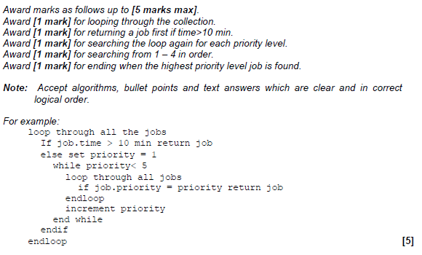

1. (a) Identify **two** differences and **two** similarities between a bubble sort and a selection sort

when sorting an array of 10 elements. [4]

*Award* ***[2 marks max]*** *for the similarities and* ***[2 marks max]*** *for the differences.*

Both use nested loops;

Each time reducing the inner loop;

Bubble sort swaps adjacent items each time it goes through the list;

Selection sort finds the next smallest each time it goes through the list;

Bubble sort can exit early if already sorted;

A cycling tour lasts for 15 days. The total time for each competitor is recorded in a

one-dimensional array, TIMES[]. After each day’s race, the array entry for each competitor

is increased by their time for that day.

There are 150 competitors and the 10 fastest times are transferred to the array FASTEST[]

and displayed on a screen each day.

1. Explain why a selection sort would be more efficient than a bubble sort in this case. [2]

*Award* ***[1 mark]*** *for reference to the size of the list and* ***[1 mark]*** *for stating why the selection sort is faster.*

It is possible that selection sort will only need 10 passes of the outer loop to find

10 fastest times;

But bubble sort will need to complete the procedure for the entire list every time;

**OR**

List is long;

Swapping takes longer than selecting;

1. Construct an algorithm to transfer the 10 fastest times from the array TIMES[] to the

array FASTEST[]. Assume that the array TIMES[] is not sorted. [6]

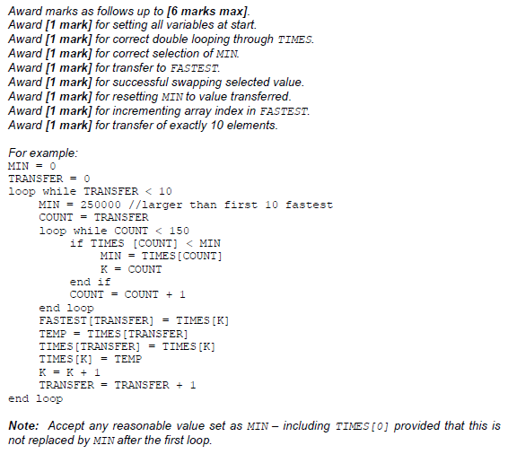

*Alternatively the array can be sorted and then transferred in which case award marks as follows:*

*Award* ***[1 mark]*** *for creating the array FASTEST.*

*Award* ***[1 mark]*** *for correct double looping through TIMES.*

*Award* ***[1 mark]*** *for comparing adjacent values.*

*Award* ***[1 mark]*** *for correct swap if second value is lower.*

*Award* ***[1 mark]*** *for looping through FASTEST.*

*Award* ***[1 mark]*** *for transferring first TIMES to FASTEST.*

The race organizers need to display the names of the 10 fastest competitors, as well as  
their times, on the screen. There is another array, NAMES[], which contains the names of  
all competitors in the same order as their times in TIMES[] (for example, NAMES[5] and  
TIMES[5] are the name and time of the same competitor).

1. Compare the use of two arrays, to hold the competitor’s times and names, with the use

of objects. [3]

The problem with parallel arrays is the sorting/indexing/maintaining relationship;

An object would contain at least a name and a time (accept other descriptions of object);

Would only need to sort the array of objects / only one list to be sorted;